**EMMETRA ASSIGNMENT REPORT**

**Assignment - 2 : Denoise and Sharpness Techniques**

**Introduction**

The report aims to provide a comprehensive analysis of how the various denoise techniques and metrics interplay to enhance image quality. Through experimental results and comparisons, the study offers insights into the strengths and limitations of various approaches, guiding the selection of optimal techniques for specific image processing tasks.

**Need for denoising and sharpness**

The purpose of denoising and sharpening techniques is to enhance image quality by reducing noise and improving edge clarity, making images more visually appealing and suitable for analysis. Metrics like edge strength and SNR are essential for objectively evaluating the effectiveness of these techniques, ensuring optimal performance for various applications.

**Key Features implemented**

* Median filtering

Median filtering is a non-linear image processing technique widely used to remove salt-and-pepper noise (impulse noise) from images while preserving edges. It replaces each pixel's value with the median of the intensity values in its neighborhood. Unlike linear filters, median filtering is effective at reducing noise without significantly blurring edges, making it ideal for preserving image details.

* Gaussian filtering

Gaussian filtering is a linear smoothing technique that uses a Gaussian function to compute a weighted average of the neighboring pixel intensities. This filter effectively reduces Gaussian noise by giving higher weights to closer pixels, resulting in a natural and smooth blur. Although it reduces noise, Gaussian filtering may slightly blur edges, making it less effective in scenarios requiring sharp edge preservation.

* Bilateral filtering

Bilateral filtering is an advanced non-linear technique that smoothens images while preserving edges. It considers both spatial proximity and intensity similarity when averaging neighboring pixel values, ensuring that pixels with similar intensities are weighted more heavily. This makes it highly effective for noise reduction in images where edge details must remain intact, such as medical or artistic applications.

* AI model

The denoising AI model will use Convolutional Neural Networks (CNNs), specifically pre-trained architectures like U-Net and FFDNet. U-Net's structure captures context and detail effectively while minimizing training time. The model will implement convolutional layers to optimize noise reduction. Performance will be evaluated using spatial Signal to Noise Ratio (SNR) for different gray tones and compared to traditional denoising methods, showcasing enhancements in image quality.

* Spatial signal to noise ratio

Spatial Signal-to-Noise Ratio (SNR) is a measure used to evaluate the quality of an image by quantifying the relationship between the desired signal (image information) and the noise present within the spatial domain of the image. It is expressed as the ratio of the signal power to the noise power, often in decibels (dB). Higher the SNR value the better is the degree of denoising of an image.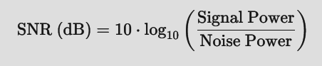

* Laplacian filter for edge enhancement

The Laplacian filter is a second-order derivative filter used in image processing to detect and enhance edges. It works by highlighting regions of rapid intensity changes, such as edges, while ignoring areas with smooth intensity variations. This makes it effective for edge enhancement and sharpening in images.

* Edge strength using gradient based processes

Gradient-based approaches, such as the Sobel filter, are commonly used for edge detection and measuring edge strength in images. These techniques calculate the gradient of the image intensity to identify regions with rapid changes, which typically correspond to edges.

**Libraries used**

The following libraries have been made use of in this assignment:

* OpenCV (Open Source Computer Vision Library) : a powerful open-source library for computer vision and image processing tasks, offering tools for real-time image analysis, feature detection, and video processing.
* Matplotlib : a popular Python library for creating static, interactive, and animated visualizations. It is widely used for data visualization in scientific and analytical applications.
* NumPy : a fundamental Python library for numerical computing, providing support for multi-dimensional arrays, mathematical functions, and efficient operations on large datasets. It serves as the backbone for scientific computing and forms the foundation for libraries like SciPy, Pandas, and TensorFlow.

**Workflow of the Project**

* The python script ‘denoise.py’ gives the comparison of median, gaussian and bilateral filtered images alongside the original image for a better understanding of the optima technique that could be used for denoising the image.
* The python script ‘modeltraining.py’ contains the model training part of the denoise CNN model.
* The python script ‘denoiseAI.py’ gives the denoised image for RAW input image for the trained denoise CNN model.
* The python script ‘snr.py’ gives the SNR values of the three gray tones of any filtered techniques used in the image processing.
* The python script ‘laplacian.py’ gives the edge enhancement using Laplacian filter on the given RAW image.
* The python script ‘strength.py’ gives the edge strength visually of the input RAW image using gradient based approaches like Sobel filter.

**Observation**

**Median filtering**

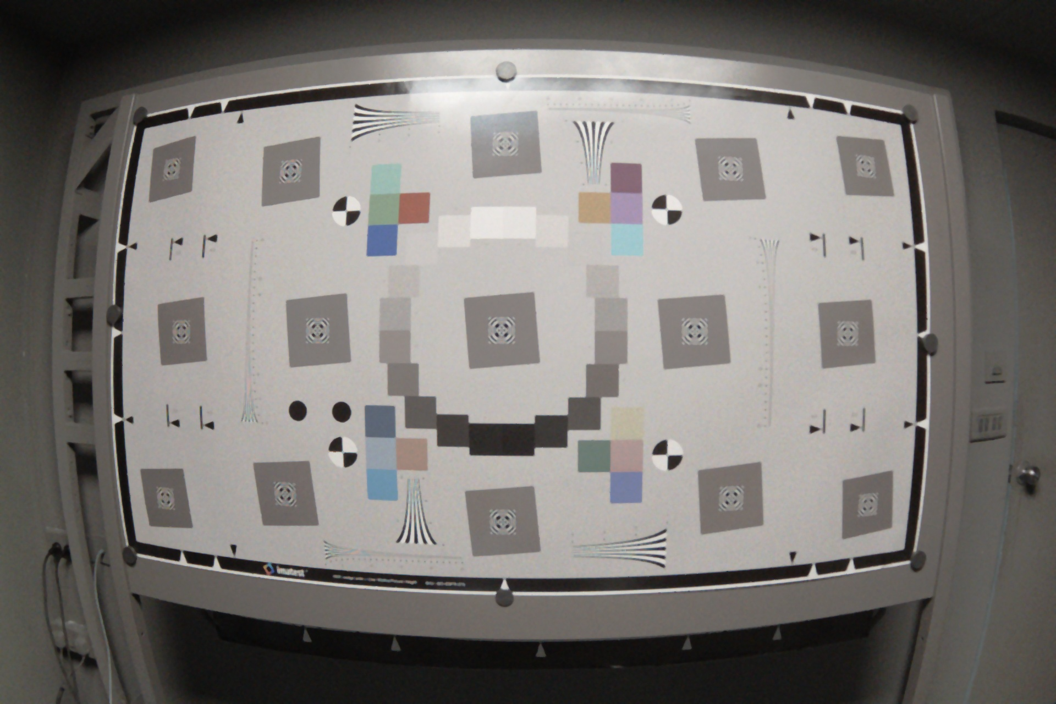

**Gaussian filter**

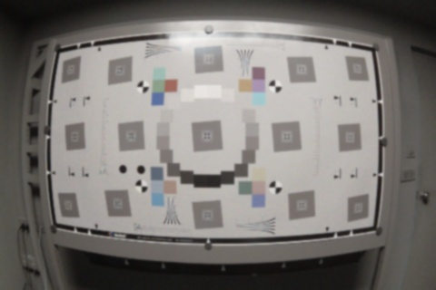

**Bilateral filter**

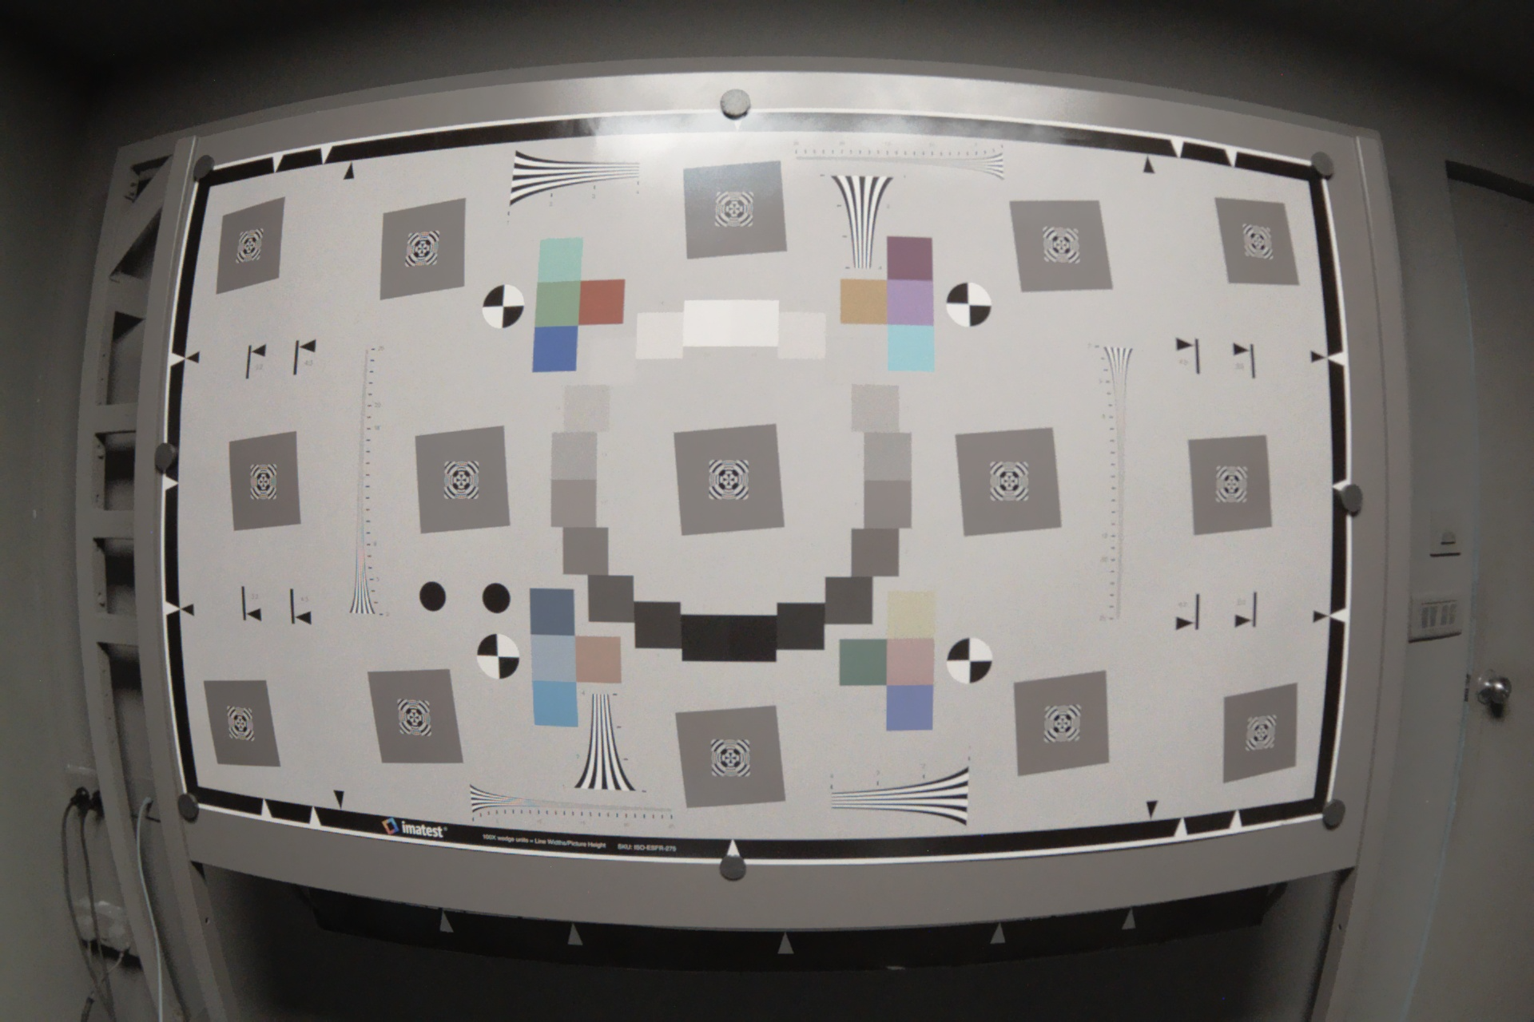

**Denoise AI model**

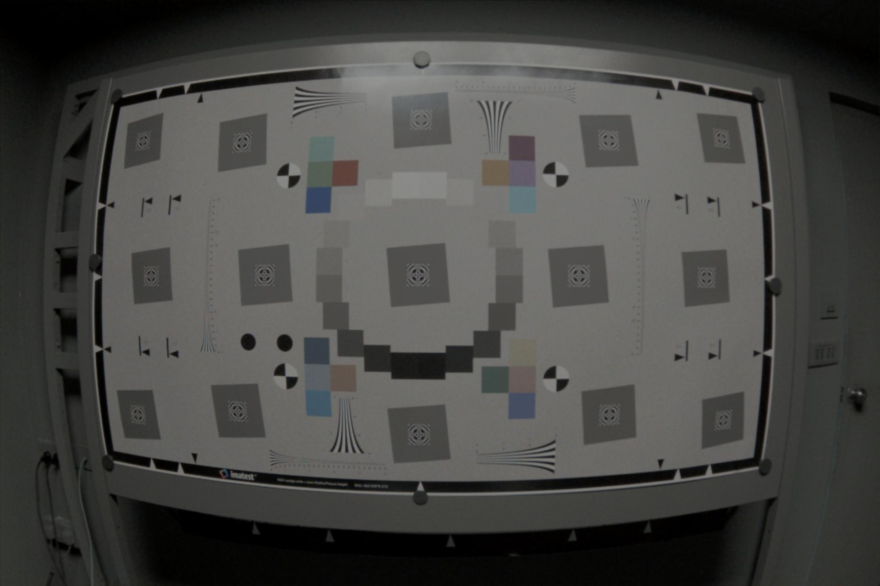

**Laplacian filter**

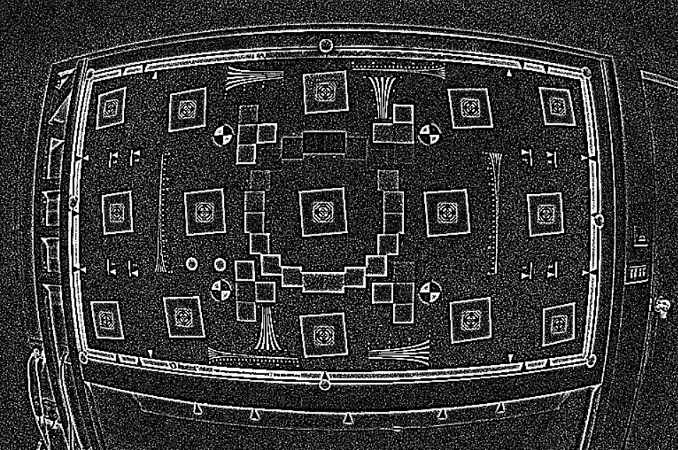

**Edge Strength**

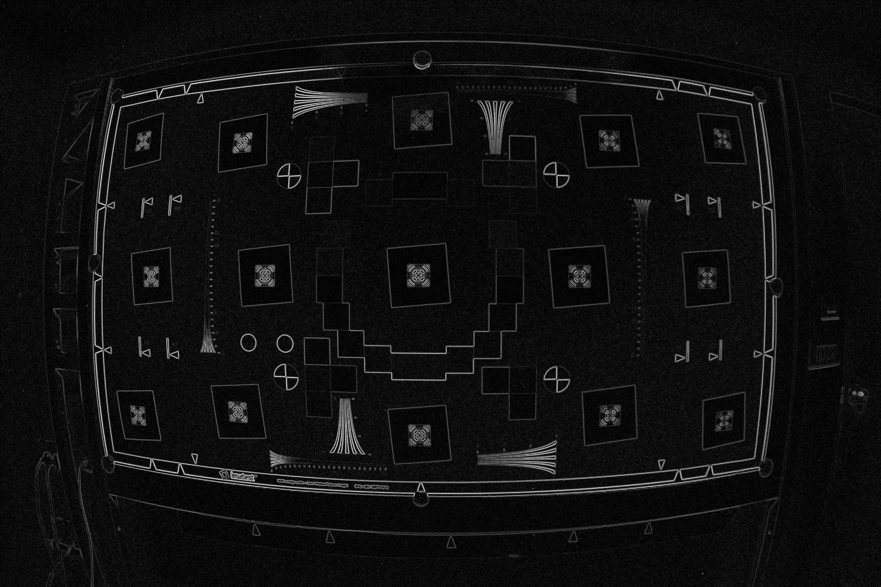

**Conclusion**

Denoising and sharpening techniques, such as median, Gaussian, bilateral, and Laplacian filters, play crucial roles in enhancing image quality by reducing noise and emphasizing important details like edges. Image quality assessment metrics like edge strength and SNR provide objective means to evaluate these methods. By balancing noise reduction and edge preservation, these techniques optimize image clarity and sharpness for various applications. The continuous evolution of these methods ensures more accurate and efficient image processing in diverse fields.